MANIPAL UNIVERSITY JAIPUR
SCHOOL OF COMPUTER SCIENCE AND ENGINEERING
DEEP LEARNING
PROJECT REPORT
Deep Learning Based Intrusion Detection
for IoT Networks Using the CICIoT2023 Dataset
Submitted by
NAMRATA KOTHARI
Manipal University Jaipur
Academic Project Report
October 2026

TABLE OF CONTENTS
1. Introduction
2. Problem Statement
3. Aim, Objectives and Research Questions
4. Literature Review
5. Dataset and Experimental Setup
6. Deep Learning Model Architectures
7. Evaluation Metrics
8. Results and Analysis
9. Comparison with State of the Art
10. Discussion
11. Limitations
12. Future Scope
13. Conclusion
14. References
Appendix A: Detailed Experimental Results
Appendix B: Model Architecture Summary
Note: Page numbers may be refreshed automatically in Microsoft Word after opening the document.

PROJECT OVERVIEW
This project presents a controlled comparison of seven deep learning architectures for multiclass intrusion detection in IoT network traffic. The current experiment uses an eight-class CICIoT2023-based configuration and evaluates a baseline DNN, DNN with Dropout, DNN with L2 regularisation, Proposed DNN, GRU, LSTM and an improved Transformer.
The study considers predictive performance and computational cost together. Accuracy is reported alongside macro precision, macro recall and macro F1, while training time is used as a practical indicator of model complexity. The current training pool contains 80,000 balanced samples, followed by an 80/20 stratified train-validation split; the supplied test set contains 268,463 flows with its natural class distribution.
A key change from the earlier project version is that GRU now replaces the previous 1D CNN model, and the Transformer results correspond to the improved current architecture. Earlier 1D CNN and older Transformer results are not used in this report.

ABSTRACT
The increasing deployment of Internet of Things (IoT) devices has expanded both the scale of network communication and the attack surface available to adversaries. IoT intrusion detection therefore requires models capable of distinguishing benign traffic from multiple malicious behaviours while maintaining acceptable computational cost. This project investigates deep learning approaches for multiclass IoT intrusion detection using a supplied CICIoT2023-based experimental configuration.
Seven architectures are evaluated under the current experiment: DNN, DNN + Dropout, DNN + L2, Proposed DNN, GRU, LSTM and an improved Transformer. The experiment uses 39 standardized numerical features and eight target classes. The balanced training pool contains 80,000 samples, while the supplied test set contains 268,463 flows. Models are compared using accuracy, macro precision, macro recall, macro F1 and training time.
The DNN achieves the highest accuracy at 75.44% and the highest macro F1 at 63.46%. DNN + L2 is the fastest model at 18.46 seconds and remains close to the baseline with 75.08% accuracy and 63.05% macro F1. The improved Transformer achieves the highest macro precision (65.39%) and macro recall (71.05%), but requires 3,497.91 seconds of training. GRU is the stronger recurrent model, reaching 69.82% accuracy and 58.68% macro F1, whereas LSTM records 55.24% accuracy and 45.71% macro F1.
The findings show that increased architectural complexity does not automatically translate into superior overall performance. Within the current experimental configuration, simpler feed-forward architectures provide the strongest balance of predictive performance and training efficiency, while the Transformer offers strong macro precision and recall at a substantially higher computational cost.
Keywords: Deep Learning; Internet of Things; Intrusion Detection System; CICIoT2023; DNN; GRU; LSTM; Transformer; Network Security; Multiclass Classification

1. INTRODUCTION
The Internet of Things represents a large ecosystem of connected sensors, cameras, smart appliances, gateways, industrial controllers and embedded systems. These devices continuously exchange data and often operate under resource and connectivity constraints. Their widespread connectivity provides significant benefits, but it also increases the number of potential entry points for attackers.
Intrusion Detection Systems (IDS) monitor network or host activity and attempt to identify malicious behaviour. Signature-based systems are effective when known attack patterns have already been encoded, but their dependence on predefined signatures can limit their ability to recognise previously unseen behaviour. Learning-based IDS approaches instead attempt to learn statistical or nonlinear patterns directly from traffic data.
Deep learning is relevant to this problem because neural networks can learn nonlinear relationships among network-flow features. Different architectures introduce different inductive biases. Fully connected networks learn global feature interactions, recurrent models process an ordered representation as a sequence, and Transformers use self-attention to model relationships among feature tokens.
However, accuracy alone is insufficient for evaluating an IDS. IoT traffic is often imbalanced, so a model can obtain a high overall accuracy while performing poorly on less frequent attack categories. Computational cost is also important when models may eventually be retrained or deployed in resource-constrained environments.
This project therefore focuses on a controlled internal comparison of seven architectures using the same current experimental setting. The goal is to identify the strongest model in this experiment while understanding the trade-off between predictive performance, regularisation, recurrent processing, attention and computational cost.

2. PROBLEM STATEMENT
The central problem addressed by this project is the automatic detection and classification of malicious IoT network traffic using deep learning. The task is formulated as an eight-class multiclass classification problem in which a model receives 39 standardized network-flow features and predicts one of the classes defined by the current experiment.
The study addresses four practical questions: whether deep neural architectures can provide reliable classification, whether regularisation improves a baseline DNN, whether recurrent architectures offer an advantage over feed-forward models, and whether the additional computational cost of more complex architectures is justified by their predictive performance.
- How well do the evaluated architectures classify the eight traffic classes?
- Do Dropout and L2 regularisation improve the baseline DNN?
- Does GRU or LSTM provide an advantage when the 39 features are represented as a sequence?
- Does the improved Transformer provide better predictive performance than the simpler models?
- What is the relationship between predictive quality and training cost?

3. AIM, OBJECTIVES AND RESEARCH QUESTIONS

3.1 Aim
To analyse and compare deep learning architectures for IoT intrusion detection under the current CICIoT2023-based eight-class experimental configuration.

3.2 Objectives
- Study IoT intrusion detection as a multiclass deep learning problem.
- Use a common preprocessing and evaluation configuration for all seven models.
- Compare DNN, DNN + Dropout, DNN + L2, Proposed DNN, GRU, LSTM and Transformer.
- Evaluate accuracy, macro precision, macro recall and macro F1.
- Measure training time as an indicator of computational cost.
- Identify the strongest model under the current experimental configuration.
- Analyse predictive-performance versus computational-cost trade-offs.
- Compare the observed behaviour with the supplied literature while accounting for differences in task design.
- Identify limitations and future directions for improving the IDS.

3.3 Research Questions
- RQ1: Which evaluated architecture gives the best predictive performance in the current eight-class experiment?
- RQ2: Do Dropout and L2 regularisation improve the baseline DNN?
- RQ3: How do GRU and LSTM compare with the feed-forward architectures?
- RQ4: Does the improved Transformer justify its additional computational cost?
- RQ5: What methodological factors should be considered before comparing the results with published CICIoT2023 results?

4. LITERATURE REVIEW
The supplied project literature review covers reviews, surveys and experimental studies concerning IoT intrusion detection, CICIoT2023 and deep learning. The review identifies recurring themes including the evolution of IDS methods, dataset selection, comparison of classical machine learning and deep learning, and the reliability of reported evaluation results.

4.1 Evolution of IoT Intrusion Detection
IDS research has progressed from rule-based and signature-oriented systems toward anomaly detection and learning-based approaches. Recent research increasingly investigates CNNs, LSTMs, Transformers, federated learning, explainable AI and edge-oriented deployment. The literature also emphasises that benchmark accuracy should be complemented by metrics such as macro F1 and by operational measures such as latency, throughput and memory.

4.2 CICIoT2023 and Evaluation Reliability
The supplied review identifies CICIoT2023 as a frequently used modern IoT intrusion-detection benchmark. Reported studies use different label spaces, subsets, balancing strategies and train-test designs. Consequently, apparently similar accuracy values may represent substantially different classification tasks.

4.3 Evidence from Deep Learning Studies
The reviewed literature contains strong results for enhanced LSTM, hybrid CNN-LSTM, CatBoost and other hybrid approaches. However, these results are not directly comparable to the current experiment because they use different class counts, sample sizes, preprocessing pipelines or evaluation settings. The literature therefore supports cautious interpretation rather than a universal ranking.

4.4 Class Imbalance
A recurring issue in IoT intrusion detection is class imbalance. The supplied literature includes examples where a high accuracy is accompanied by a much lower macro F1, demonstrating that dominant classes can mask poor minority-class detection. This motivates the use of macro-averaged metrics in the current project.

4.5 Research Gap
- Limited cross-dataset generalisation evaluation.
- Insufficient adversarial-robustness evaluation.
- Limited quantitative validation of explainability.
- Limited production and streaming validation.
- Insufficient reporting of computational cost, memory and energy.
- Need for stronger minority-class and natural-distribution evaluation.
Study | Representative model | Task/classes | Reported result | Comparability note
Kwari & Rajkumar (2025) | Soft-voting ensemble | 34 classes | 76.88% accuracy | Natural imbalance; macro-F1 much lower
Meena & Indian (2025) | Enhanced LSTM | 34 classes | 98.58% accuracy | Different task and data scale
Imran et al. (2026) | LSTM | 6 classes | 96.02% accuracy | Different task and datasets
Hajjouz & Avksentieva (2024) | CatBoost | 20 classes | 99.96% accuracy | Class weighting and six-fold validation
Yaras & Dener (2024) | 1D-CNN + LSTM | Binary / multiclass | 99.995% / 99.96% | Different task and setup

5. DATASET AND EXPERIMENTAL SETUP

5.1 Dataset Context
The project uses the CICIoT2023 dataset context because it is a major benchmark in the supplied literature. The dataset is intended to represent diverse IoT network behaviour and attack activity. The current notebook uses a derived eight-class experimental configuration rather than attempting to reproduce every class in the original benchmark.

5.2 Current Experimental Configuration
Item | Current value
Dataset context | CICIoT2023
Training pool | 80,000 balanced samples
Validation split | 20% stratified from the training pool
Test set | 268,463 flows with natural class distribution
Number of classes | 8
Input features | 39 standardized numerical features
Models | DNN; DNN + Dropout; DNN + L2; Proposed DNN; GRU; LSTM; Transformer
Metrics | Accuracy; Macro Precision; Macro Recall; Macro F1
Cost metric | Training time in seconds

5.3 Class Labels
- Benign
- BruteForce
- DDoS
- DoS
- Mirai
- Recon
- Spoofing
- Web-based

5.4 Experimental Workflow
The experimental workflow consists of data preparation, class balancing for the training pool, stratified train-validation splitting, feature scaling, model construction, model training, test evaluation and cross-model comparison. All seven models are evaluated under the same current experiment so that observed differences are attributable primarily to architecture and training configuration.

5.5 Input Representation
The DNN-family models receive the 39-feature vector directly. GRU and LSTM reshape the representation to 39 timesteps with one value per timestep. The Transformer also represents the 39 numerical features as feature tokens, with learnable embeddings, positional information and a learnable CLS token.

5.6 Reproducibility
For future reproduction, the project should retain the exact feature list, preprocessing pipeline, class mapping, random seed, split generation, model architecture, optimiser, learning rate, batch size, number of epochs and hardware configuration. These details are important because small implementation differences can change neural-network results.

6. DEEP LEARNING MODEL ARCHITECTURES
The current experiment intentionally compares three architecture families: feed-forward dense models, recurrent models and an attention-based Transformer. The seven models are trained for the same classification task.

6.1 DNN
39 → Dense(128, ReLU) → Dense(64, ReLU) → Dense(32, ReLU) → Softmax(8). The DNN is the primary feed-forward baseline.

6.2 DNN + Dropout
39 → Dense(128) → Dropout(0.30) → Dense(64) → Dropout(0.30) → Dense(32) → Softmax(8). Dropout tests stochastic regularisation.

6.3 DNN + L2
39 → Dense(128, L2=0.001) → Dense(64, L2=0.001) → Dense(32) → Softmax(8). L2 tests weight regularisation.

6.4 Proposed DNN
39 → Dense(128, L2) → BatchNorm → Dropout(0.30) → Dense(64, L2) → Dropout(0.30) → Dense(32) → Dropout(0.20) → Softmax(8). This combines several regularisation mechanisms.

6.5 GRU
39×1 → GRU(64, return sequences) → Dropout(0.20) → GRU(32) → Dense(64, ReLU) → Dropout(0.20) → Softmax(8). GRU replaces the previous 1D CNN in the current experiment.

6.6 LSTM
39×1 → LSTM(64, return sequences) → Dropout(0.30) → LSTM(32) → Dropout(0.30) → Dense(64, ReLU) → Softmax(8).

6.7 Improved Transformer
Feature tokenizer (64 dimensions) → learnable position embeddings → CLS token → two pre-normalised Transformer encoder blocks with four attention heads → LayerNorm → CLS representation → Dense(64, GELU) → Dropout(0.15) → Softmax(8). AdamW is used with learning rate 1e-4 and weight decay 1e-4.

7. EVALUATION METRICS
The project does not rely on accuracy alone. Macro-averaged precision, recall and F1 give each class equal weight and are therefore more informative when class frequencies are uneven.
Metric | Meaning | Why it matters for IDS
Accuracy | Fraction of all predictions that are correct. | Useful overall measure, but can be dominated by frequent classes.
Macro Precision | Average precision across the eight classes. | Shows how reliably predicted attack classes correspond to the true class.
Macro Recall | Average recall across the eight classes. | Indicates how well the model detects each class rather than only dominant classes.
Macro F1 | Harmonic mean of macro precision and macro recall. | Provides a balanced summary of precision and recall across classes.
Training Time | Wall-clock time required to train the model in the recorded experiment. | Provides a relative indicator of computational cost and retraining burden.

For multiclass classification, the exact implementation of averaging matters. The values in this report are the macro metrics recorded in the current notebook experiment and should be interpreted within that implementation.

8. RESULTS AND ANALYSIS

8.1 Overall Results
Model | Accuracy | Macro Precision | Macro Recall | Macro F1 | Training Time (s)
DNN | 75.44% | 64.03% | 70.31% | 63.46% | 19.48
DNN + Dropout | 73.73% | 63.91% | 69.02% | 62.10% | 21.84
DNN + L2 | 75.08% | 63.43% | 68.96% | 63.05% | 18.46
Proposed DNN | 74.07% | 64.51% | 68.98% | 62.26% | 25.70
GRU | 69.82% | 60.34% | 65.51% | 58.68% | 668.69
LSTM | 55.24% | 52.20% | 51.43% | 45.71% | 173.61
Transformer | 72.53% | 65.39% | 71.05% | 62.63% | 3497.91

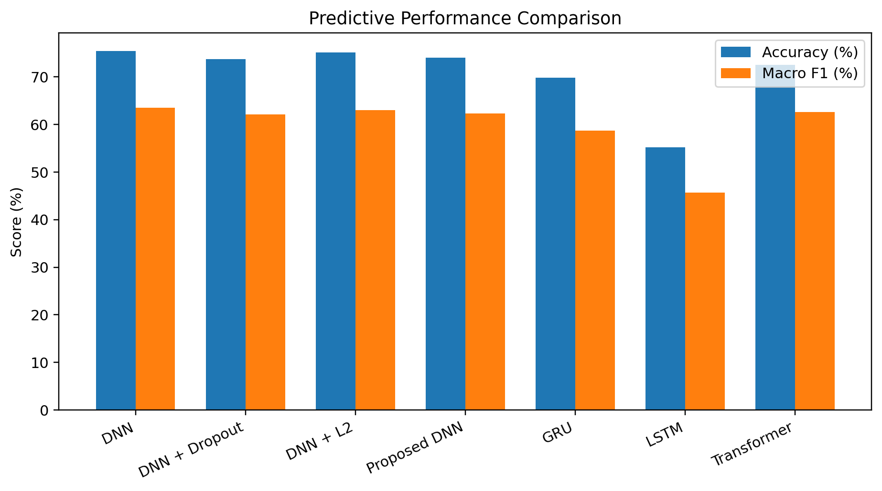
Figure 1. Accuracy and macro F1 comparison across the seven current models.

8.2 Accuracy and Macro F1
The DNN records the highest accuracy at 75.44%, followed closely by DNN + L2 at 75.08%. The Proposed DNN and DNN + Dropout remain competitive at 74.07% and 73.73%, respectively. The Transformer reaches 72.53%, while GRU reaches 69.82%. LSTM records the lowest accuracy at 55.24%.
The macro-F1 ranking is similar but not identical. DNN leads at 63.46%, DNN + L2 follows at 63.05%, and Transformer reaches 62.63%. The Transformer therefore remains competitive on class-balanced predictive quality despite its lower accuracy than the DNN-family models.

8.3 Precision and Recall
The Transformer records the highest macro precision at 65.39% and the highest macro recall at 71.05%. This is an important distinction from the accuracy ranking: the Transformer is not the best model by overall accuracy, but it produces the strongest macro-averaged precision and recall in the current experiment.

8.4 Training-Time Analysis
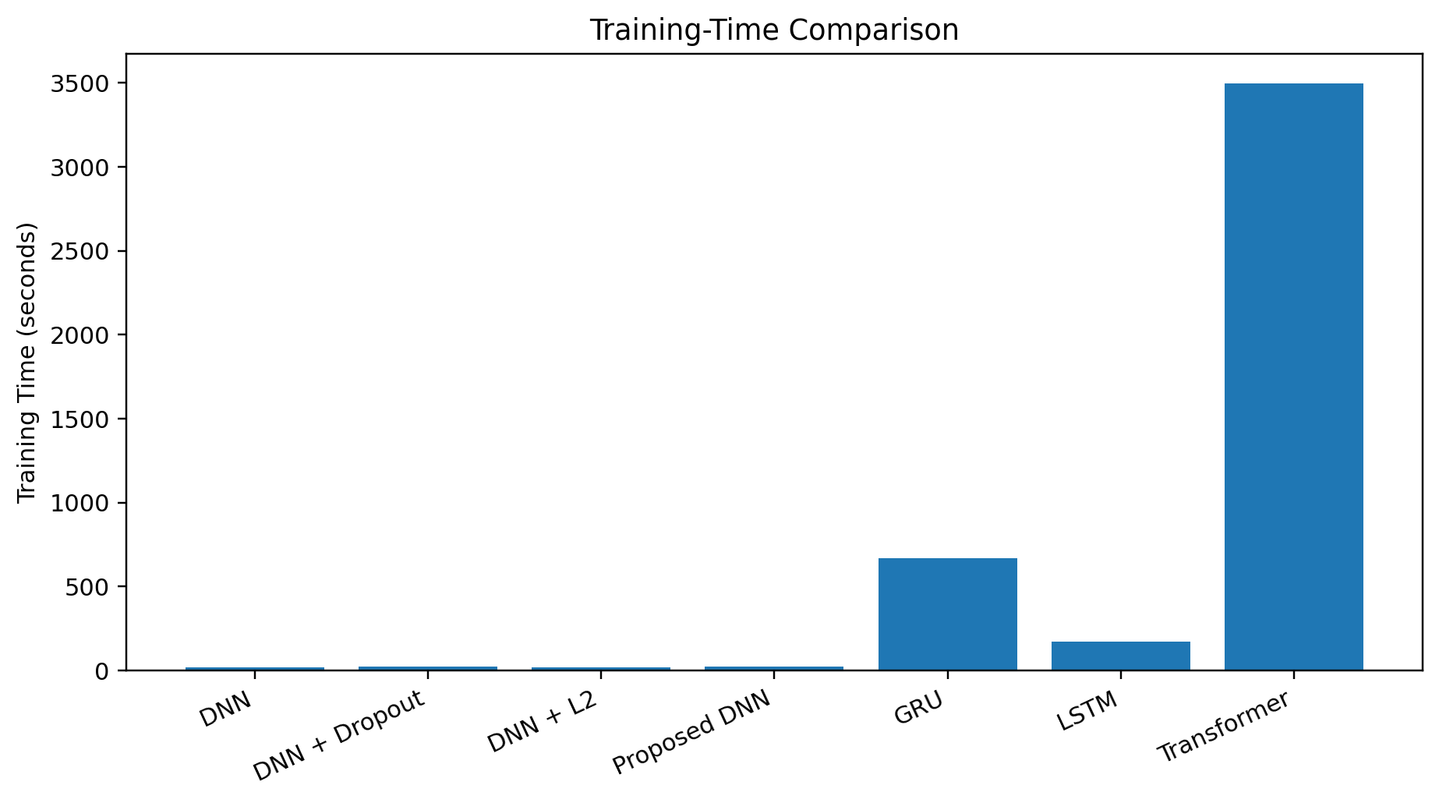
Figure 2. Training-time comparison across the seven current models.
DNN + L2 is the fastest model at 18.46 seconds, followed by DNN at 19.48 seconds. The four feed-forward models all train within approximately 18–26 seconds. LSTM requires 173.61 seconds, GRU requires 668.69 seconds, and the Transformer requires 3,497.91 seconds. The large increase in training cost does not produce a corresponding increase in overall accuracy.

8.5 Model-by-Model Interpretation
DNN: Best overall predictive model by accuracy and macro F1. It also has very low training cost, making it the strongest overall baseline in the current experiment.
DNN + Dropout: Competitive but slightly below the baseline DNN on accuracy and macro F1. The result indicates that the selected dropout configuration did not provide an advantage in this run.
DNN + L2: Nearly matches the DNN while being the fastest model. This makes it particularly attractive when training efficiency is prioritised.
Proposed DNN: Combines L2, Batch Normalization and Dropout. It remains competitive but does not exceed the simpler DNN or DNN + L2 configurations.
GRU: The strongest recurrent model. It outperforms LSTM on all four predictive metrics but requires substantially more training time than the feed-forward models.
LSTM: Lowest predictive performance in the current comparison. Its result suggests that the sequential representation used in the experiment does not provide an advantage for this task.
Transformer: Strongest macro precision and recall, but its training cost is much higher than every other model. The result highlights the need to evaluate attention-based architectures together with computational cost.

8.6 Ranking
Rank | Model | Accuracy | Macro F1 | Training Time (s)
1 | DNN | 75.44% | 63.46% | 19.48
2 | DNN + L2 | 75.08% | 63.05% | 18.46
3 | Proposed DNN | 74.07% | 62.26% | 25.70
4 | DNN + Dropout | 73.73% | 62.10% | 21.84
5 | Transformer | 72.53% | 62.63% | 3497.91
6 | GRU | 69.82% | 58.68% | 668.69
7 | LSTM | 55.24% | 45.71% | 173.61

8.7 Performance–Cost Trade-off
The strongest practical observation is the gap between model complexity and measured training cost. DNN + L2 reaches 75.08% accuracy in 18.46 seconds, while the Transformer reaches 72.53% accuracy in 3,497.91 seconds. Thus, the current results do not support the assumption that a more complex architecture automatically provides better overall performance.
Training time should not be interpreted as deployment inference latency. It is used here as a relative indicator of training and retraining cost. A production IDS would require separate measurements of inference latency, throughput, memory and energy.

9. COMPARISON WITH STATE OF THE ART
Published CICIoT2023 results should be compared cautiously because studies use different class definitions, sampling strategies, feature sets, balancing procedures and evaluation protocols. The supplied literature includes binary, six-class, eight-class, 20-class and 34-class tasks. A near-perfect result on a binary task is therefore not directly comparable to the current eight-class experiment.
Study / Experiment | Representative model | Classes | Accuracy | Context
Kwari & Rajkumar (2025) | Soft-voting ensemble | 34 | 76.88% | Natural imbalance; subset
Meena & Indian (2025) | Enhanced LSTM | 34 | 98.58% | Different data scale and task
Imran et al. (2026) | LSTM | 6 | 96.02% | CICIoT2023 + IoT-23; different task
Hajjouz & Avksentieva (2024) | CatBoost | 20 | 99.96% | Class weighting; six-fold validation
Yaras & Dener (2024) | 1D-CNN + LSTM | Binary / multiclass | 99.995% / 99.96% | Different task/setup
This project | DNN | 8 | 75.44% | 80k balanced training pool; 268,463-flow test set

The current project's purpose is therefore not to claim a universal SOTA ranking. Its contribution is a controlled comparison among seven architectures under one consistent eight-class experimental configuration. The result is best interpreted as an internal benchmark for model selection and further optimisation.

10. DISCUSSION
The current results demonstrate that the relationship between architecture and performance depends strongly on the task representation and training configuration. The DNN is the strongest overall model by accuracy and macro F1, while DNN + L2 provides almost the same predictive quality at the lowest training cost.
The regularisation experiments are informative because neither Dropout nor the combined Proposed DNN improves the baseline DNN in the current run. This does not imply that regularisation is ineffective in general. Instead, it indicates that the selected regularisation strengths and architecture were not superior under this particular data and optimisation setting.
The recurrent comparison shows a clear advantage for GRU over LSTM. GRU achieves 69.82% accuracy and 58.68% macro F1, compared with 55.24% and 45.71% for LSTM. Nevertheless, GRU requires 668.69 seconds of training, much more than the feed-forward models.
The improved Transformer provides a different perspective. It records the highest macro precision and recall, suggesting strong class-balanced behaviour on these metrics, but its 3,497.91-second training time is substantially larger than that of every other architecture. This makes it an interesting accuracy/metric candidate but a poor efficiency choice under the current training configuration.
Overall, the project supports evidence-based architecture selection. A model should not be selected solely because its architecture is newer or more complex. The appropriate choice depends on the target metric, computational constraints and deployment requirements.

11. LIMITATIONS
- The report describes one current experimental configuration and does not establish universal architectural superiority.
- The training pool is balanced to 80,000 samples rather than using the full supplied training pool.
- The test set retains its natural distribution, so performance is specific to this evaluation protocol.
- The current aggregate results do not by themselves provide a complete per-class error analysis.
- Training time is reported, but inference latency, memory consumption, throughput and energy are not measured.
- The GRU and LSTM sequence representation treats the 39 features as an ordered sequence; this ordering is a modelling representation rather than an observed temporal sequence.
- Results from external literature are not directly comparable unless class definitions, sampling, preprocessing and evaluation protocols are aligned.
- No cross-dataset generalisation or adversarial-robustness experiment is included in the current results.

12. FUTURE SCOPE
- Perform systematic hyperparameter tuning for all seven architectures.
- Add class-wise precision, recall, F1, confusion matrices and balanced accuracy.
- Investigate class weighting, focal loss and alternative sampling strategies.
- Evaluate grouped or session-aware splits to reduce potential near-duplicate leakage.
- Measure inference latency, throughput, memory and energy on representative edge hardware.
- Evaluate cross-dataset generalisation using compatible IoT intrusion-detection datasets.
- Test robustness under distribution shifts and adversarial perturbations.
- Apply explainability methods such as SHAP or LIME and assess explanation stability.
- Investigate lightweight hybrid architectures for deployment-oriented IDS.
- Explore federated learning when centralised data collection is undesirable.

13. CONCLUSION
This project presented a controlled comparison of seven deep learning architectures for IoT intrusion detection using the current CICIoT2023-based eight-class experiment. The evaluated models were DNN, DNN + Dropout, DNN + L2, Proposed DNN, GRU, LSTM and an improved Transformer.
The DNN achieved the strongest overall result with 75.44% accuracy and 63.46% macro F1. DNN + L2 was the most efficient model, requiring only 18.46 seconds of training while achieving 75.08% accuracy and 63.05% macro F1. The Transformer achieved the highest macro precision and macro recall, at 65.39% and 71.05%, respectively, but required 3,497.91 seconds of training. GRU was the strongest recurrent model, outperforming LSTM by a substantial margin.
The central conclusion is that architectural complexity does not automatically produce better overall intrusion-detection performance. In the current experiment, simpler feed-forward models provide the best balance of predictive performance and computational cost. The Transformer demonstrates that different metrics can favour different architectures, reinforcing the importance of reporting macro-averaged measures rather than relying only on accuracy.
The results should be interpreted as a controlled internal benchmark rather than a universal State-of-the-Art claim. Future work should focus on class-wise analysis, stronger imbalance-aware evaluation, reproducibility, cross-dataset generalisation and deployment-oriented measurements.

14. REFERENCES
- Almahaqeri, S. A., et al. (2026). An optimized gradient boosting framework for IoT intrusion detection: a comprehensive evaluation on the CICIoT2023 dataset. Scientific Reports.
- Ahmed, A., Mostafa, R., Qutqut, M. H., & Ragab, N. (2026). A Systematic Literature Review on Machine Learning for Intrusion Detection Systems. Future Internet, 18, 470.
- Bunko, T., Johnstone, M. N., Yang, W., & Scott, B. A. (2026). A survey of privacy-preserving federated learning for intrusion detection systems. Artificial Intelligence Review, 59, 125.
- Hajjouz, A., & Avksentieva, E. (2024). Optimizing Intrusion Detection for DoS, DDoS, and Mirai Attacks Subtypes Using Hierarchical Feature Selection and CatBoost on the CICIoT2023 Dataset. Data and Metadata, 3, 577.
- Imran, S., et al. (2026). An Explainable AI-Driven Intrusion Detection Framework for IoT Networks Using Deep Learning and Machine Learning Models. Journal of Computers and Intelligent Systems, 4(2), 99–116.
- Khan, M. Z., et al. (2026). A resource efficient IoT intrusion detection model using hybrid feature selection for edge computing. Scientific Reports.
- Kwari, M. I., & Rajkumar, N. (2025). An Enhanced Voting Ensemble Model for IoT Intrusion Detection Using the CICIoT2023 Dataset. IGCAI 2025, 67–77.
- Meena, G., & Indian, A. (2025). IDS-IoT: Intrusion Detection System for the Internet of Things Using Enhanced Long-Short Term Memory. Artificial Intelligence and Applications.
- Mishra, S., & Reddy, R. V. S. (2026). Federated Hybrid Deep Learning Framework for IoT Intrusion Detection. Preprint.
- Mondragon, J. C., et al. (2025). Advanced IDS: a comparative study of datasets and machine learning algorithms for network flow-based intrusion detection systems. Applied Intelligence, 55, 608.
- Mughogho, E. (2025). Enhancing IoT Network Security Through Intrusion Detection Using Machine Learning. MSc research project, National College of Ireland.
- Winanto, E. A., & Idris, M. Y. (2026). Adversarial Robustness of Deep Learning-Based Intrusion Detection Systems: A Systematic Literature Review. IEEE Access, 14.
- Yaras, S., & Dener, M. (2024). IoT-Based Intrusion Detection System Using New Hybrid Deep Learning Algorithm. Electronics, 13, 1053.

APPENDIX A: DETAILED EXPERIMENTAL RESULTS
The following table contains the final current model results used throughout this report.
Model | Accuracy (%) | Macro Precision (%) | Macro Recall (%) | Macro F1 (%) | Training Time (s)
DNN | 75.44 | 64.03 | 70.31 | 63.46 | 19.48
DNN + Dropout | 73.73 | 63.91 | 69.02 | 62.10 | 21.84
DNN + L2 | 75.08 | 63.43 | 68.96 | 63.05 | 18.46
Proposed DNN | 74.07 | 64.51 | 68.98 | 62.26 | 25.70
GRU | 69.82 | 60.34 | 65.51 | 58.68 | 668.69
LSTM | 55.24 | 52.20 | 51.43 | 45.71 | 173.61
Transformer | 72.53 | 65.39 | 71.05 | 62.63 | 3497.91

Appendix A.1 Final Takeaways
- Best accuracy: DNN — 75.44%.
- Best macro F1: DNN — 63.46%.
- Best macro precision: Transformer — 65.39%.
- Best macro recall: Transformer — 71.05%.
- Fastest training: DNN + L2 — 18.46 seconds.
- Best recurrent model: GRU — 69.82% accuracy and 58.68% macro F1.
- Highest training cost: Transformer — 3,497.91 seconds.

APPENDIX B: MODEL ARCHITECTURE SUMMARY
Model | Architecture summary
DNN | 39 → 128 → 64 → 32 → Softmax(8)
DNN + Dropout | 39 → 128 → Dropout(0.30) → 64 → Dropout(0.30) → 32 → Softmax(8)
DNN + L2 | 39 → 128(L2=0.001) → 64(L2=0.001) → 32 → Softmax(8)
Proposed DNN | 39 → 128(L2) → BatchNorm → Dropout → 64(L2) → Dropout → 32 → Dropout → Softmax(8)
GRU | 39×1 → GRU(64) → Dropout → GRU(32) → Dense(64) → Dropout → Softmax(8)
LSTM | 39×1 → LSTM(64) → Dropout → LSTM(32) → Dropout → Dense(64) → Softmax(8)
Transformer | Feature tokenizer(64) → position embedding → CLS → 2 encoder blocks → Dense head → Softmax(8)

